PT Activity: Configuring Context-Based Access Control (CBAC)
Topology Diagram
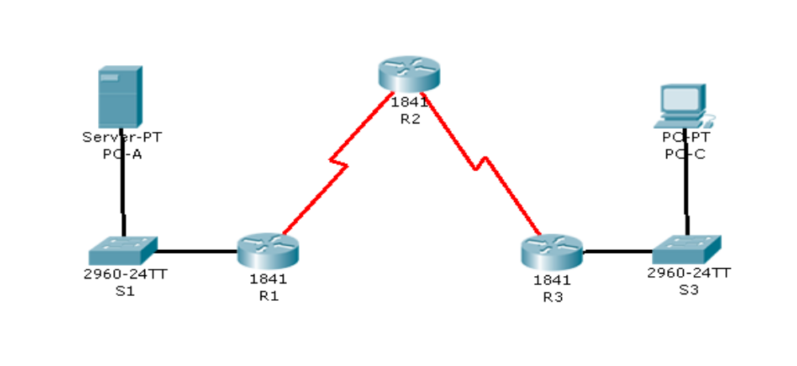
Addressing Table
Device | Interface | IP Address | Subnet Mask | Default Gateway
R1 | Fa0/1 | 192.168.1.1 | 255.255.255.0 | N/A
R1 | S0/0/0 | 10.1.1.1 | 255.255.255.252 | N/A
R2 | S0/0/0 | 10.1.1.2 | 255.255.255.252 | N/A
R2 | S0/0/1 | 10.2.2.2 | 255.255.255.252 | N/A
R3 | Fa0/1 | 192.168.3.1 | 255.255.255.0 | N/A
R3 | S0/0/1 | 10.2.2.1 | 255.255.255.252 | N/A
PC-A | NIC | 192.168.1.3 | 255.255.255.0 | 192.168.1.1
PC-C | NIC | 192.168.3.3 | 255.255.255.0 | 192.168.3.1

Learning Objectives
- Verify connectivity among devices before firewall configuration.
- Configure an IOS firewall with CBAC on router R3.
- Verify CBAC functionality using ping, Telnet, and HTTP.
Introduction
Context-Based Access Control (CBAC) is used to create an IOS firewall. In this activity, you will create a basic CBAC configuration on edge router R3. R3 provides access to resources outside of the network for hosts on the inside network. R3 blocks external hosts from accessing internal resources. After the configuration is complete, you will verify firewall functionality from internal and external hosts.
The routers have been pre-configured with the following:
- Enable password: ciscoenpa55
- Password for console: ciscoconpa55
- Password for vty lines: ciscovtypa55
- IP addressing
- Static routing
- All switch ports are in VLAN 1 for switches S1 and S3.
- Block Traffic From Outside
- Verify Basic Network Connectivity.
Verify network connectivity prior to configuring the IOS firewall.
- From the PC-C command prompt, ping the PC-A server.
- From the PC-C command prompt, Telnet to the Router R2 S0/0/1 interface: IP address 10.2.2.2. Exit the Telnet session.
- From PC-C, open a web browser to the PC-A server to display the web page. Close the browser on PC-C.
- From the PC-A server command prompt, ping PC-C.
- Configure a named IP ACL on R3 to block all traffic originating from the outside network.
Use the ip access-list extended command to create a named IP ACL.
R3(config)# ip access-list extended OUT-IN
R3(config-ext-nacl)# deny ip any any
R3(config-ext-nacl)# exit
- Apply the ACL to interface Serial 0/0/1.
R3(config)# interface s0/0/1
R3(config-if)# ip access-group OUT-IN in
- Confirm that traffic entering interface Serial 0/0/1 is dropped.
From the PC-C command prompt, ping the PC-A server. The ICMP echo replies are blocked by the ACL.
- Create a CBAC Inspection Rule
- Create an inspection rule to inspect ICMP, Telnet, and HTTP traffic.
R3(config)# ip inspect name IN-OUT-IN icmp
R3(config)# ip inspect name IN-OUT-IN telnet
R3(config)# ip inspect name IN-OUT-IN http
- Turn on time-stamped logging and CBAC audit trail messages.
Use the ip inspect audit-trail command to turn on CBAC audit messages to provide a record of network access through the firewall, including illegitimate access attempts. Enable logging to the syslog server, 192.168.1.3, with the logging host command. Make sure that logged messages are timestamped.
R3(config)# ip inspect audit-trail
R3(config)# service timestamps debug datetime msec
R3(config)# logging host 192.168.1.3
- Apply the inspection rule to egress traffic on interface S0/0/1.
R3(config-if)# ip inspect IN-OUT-IN out
- Verify that audit trail messages are being logged on the syslog server.
- From PC-C, test connectivity to PC-A with ping, Telnet, and HTTP. Ping and HTTP should be successful. Note that PC-A will reject the Telnet session.
- From PC-A, test connectivity to PC-C with ping and Telnet. All should be blocked.
- Review the syslog messages on server PC-A: click the Config tab and then click the SYSLOG option.
- Verify Firewall Functionality
- Open a Telnet session from PC-C to R2.
The Telnet should succeed. While the Telnet session is active, issue the command show ip inspect sessions on R3. This command displays the existing sessions that are currently being tracked and inspected by CBAC.
R3# show ip inspect sessions
Established Sessions
Session 100424296 (192.168.3.3:1031)=>(10.1.1.2:23) telnet SIS_OPEN
What is the source IP address and port number? 192.168.3.3:1031 (port 1031 is random)
What is the destination IP address and port number? 10.1.1.2:23 (Telnet = port 23)
Exit the Telnet session.
- From PC-C, open a web browser to the PC-A server web page using the server IP address.
The HTTP session should succeed. While the HTTP session is active, issue the command show ip inspect sessions on R3.

R3# show ip inspect sessions
Established Sessions
Session 104637440 (192.168.3.3:1032)=>(192.168.1.3:http SIS_OPEN

Note: If the HTTP session times out before you execute the command on R3, you will have to click the Go button on PC-C to generate a session between PC-C and PC-A.

What is the source IP address and port number? 192.168.3.3:1027 (port 1032 is random)
What is the destination IP address and port number? 192.168.1.3:80 (HTTP web = port 80)
Close the browser on PC-C.
- View the interface configuration and inspection rule timers.
Enter the show ip inspect interfaces command on R3.
The output shows existing sessions that are currently being tracked and inspected by CBAC.
R3# show ip inspect interfaces
Interface Configuration
Interface Serial0/0/1
Inbound inspection rule is not set
Outgoing inspection rule is IN-OUT-IN
icmp alert is on audit-trail is off timeout 10
telnet alert is on audit-trail is off timeout 3600
http alert is on audit-trail is off timeout 3600
Inbound access list is OUT-IN
Outgoing access list is not set
- Review CBAC Configuration
- Display CBAC configuration.
Enter the show ip inspect config command on R3 to display the complete CBAC inspection configuration.
R3# show ip inspect config
Session audit trail is enabled
Session alert is enabled
one-minute (sampling period) thresholds are [unlimited : unlimited] connections
max-incomplete sessions thresholds are [unlimited : unlimited]
max-incomplete tcp connections per host is unlimited. Block-time 0 minute.
tcp synwait-time is 30 sec -- tcp finwait-time is 5 sec
tcp idle-time is 3600 sec -- udp idle-time is 30 sec
tcp reassembly queue length 16; timeout 5 sec; memory-limit 1024 kilo bytes
dns-timeout is 5 sec
Inspection Rule Configuration
Inspection name IN-OUT-IN
icmp alert is on audit-trail is off timeout 10
telnet alert is on audit-trail is off timeout 3600
http alert is on audit-trail is off timeout 3600
- Display real-time output that can be used for troubleshooting.
Enter the debug ip inspect detailed command on R3 to display detailed messages about CBAC software events, including information about CBAC packet processing.
From PC-C, open a web browser on PC-C; enter the PC-A (server) IP address: 192.168.1.3.
R3# debug ip inspect detailed
INSPECT Detailed Debug debugging is on
*Mar 01, 02:37:28.3737: %FW-6-SESS_AUDIT_TRAIL_START: Start http session: initiator (192.168.3.3:1039) -- responder (192.168.1.3:80)
*Mar 01, 02:37:28.3737: CBAC: Finding pregen session for src_tableid:0, src_addr:192.168.3.3, src_port:1039, dst_tableid:0, dst_addr:192.168.1.3, dst_port:80
*Mar 01, 02:37:38.3737: %FW-6-SESS_AUDIT_TRAIL_STOP: Stop http session: initiator (192.168.3.3:1041) -- responder (192.168.1.3:80)
- Check Results.
Your completion percentage should be 100%. Click Check Results to see feedback and verification of which required components have been completed.

